PROJECT SPACE AT LEWISHAM ART HOUSE

Lewisham Art House Limited is an artists-run studio co-operative located, since 1994, in a listed Carnegie building at 140 Lewisham Way, New Cross. We are just down the road from Goldsmiths College and Deptford; a thriving area for artistic activity with APT, Bearspace, SE8 and Enclave Projects all in the locality.

The Project Space offers a fantastic opportunity for artists, curators and members of the local community to realise experimental works, and contribute to an engaging and ambitious programme. Our hire fee to use the Project Space is amongst the most affordable in London. (Please see our terms and conditions for full details.) Previous events have included exhibitions from local, national and international artists and collectives, craft fairs, exhibitions from local schools, performances, gigs, pop-up food events and more. If you are a curator, artist or someone with an idea, please get in touch.

The Project Space has a wall perimeter of 106 feet, high ceilings, overhead lighting and great natural light through large windows. It is located on the main road next to a well-served bus stop (21, 36, 136 and 321) and is 5 minutes walk from New Cross Station, which has good rail and tube links to East and Central London. The venue is wheelchair accessible with an accessible toilet adjacent to the project space.

Space hires are currently 2 weeks duration under our Covid regulations. Applicants are selected on submission of an exhibition/event proposal including examples of work. Alongside the strength of the artwork/event proposed, we evaluate proposals on the basis of community engagement, originality, and how the event will sit within the wider programme of work. We aim to host a rich and varied programme of events, reflecting the talent, diversity and heritage of the local area and community. We believe in access to the arts for all, and are particularly interested in receiving proposals from individuals and groups with non-traditional artistic backgrounds, and those currently under-represented within the artistic sector and arts education.

For further information please read our terms and conditions downloadable from our website.

To apply, please send a filled in application form (below) with your proposal. We’re also happy to accept video and audio files as an alternative to written proposals. Please contact us if you have other access requirements.
APPLICATION FORM FOR PROJECT SPACE AT LEWISHAM ART HOUSE

Contact name :

Address :

Telephone :

Email :

Duration of exhibition/event :

Exhibition/Event title :

Names of other artist/s :

Website/Blog/Social media :

Tell us about your proposed project (maximum 500 words / up to 3 mins approx) :

Tell us about yourself and your work (maximum 300 words / up to 2 mins approx) :

Show us some of your previous, current or proposed work - this can be in the form of pictures (up to 5), or video / audio or other format where appropriate.

You’re welcome to include a CV - this is not essential.

Please send your proposal to : projectspace@lewishamarthouse.org.uk
Or by post to :

Project Space Co-ordinator
Lewisham Arthouse
140 Lewisham Way
London SE14 6PD

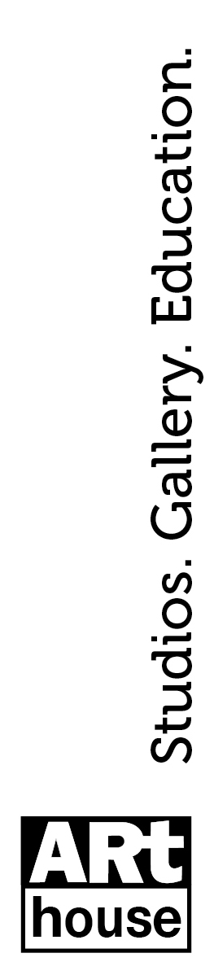
This will be given consideration at the next available Project Space meeting, you will be contacted as soon as possible after that date. All who use the Project Space must agree to abide by the General Terms and Conditions, which can be downloaded from our website.

