LEWISHAM ARTHOUSE

EQUAL OPPORTUNITIES FORM

Lewisham Arthouse is committed to recruiting and retaining a diverse and representative artist membership and staff. The information provided on this form will be treated as strictly confidential and used only to ensure that our recruitment process is being carried out fairly and in a non-discriminatory way. This form will be stored separately from your application. Completing this form is optional.

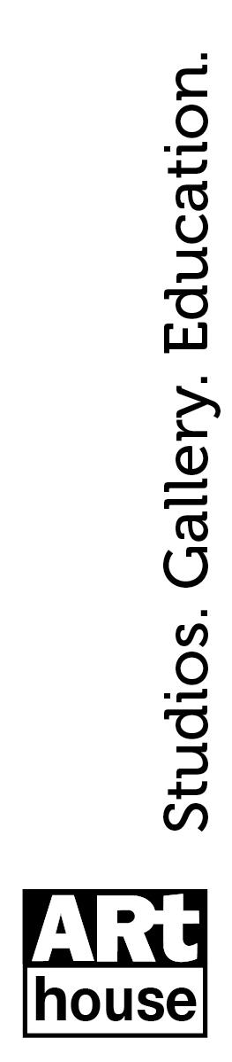

Age Please tick one

18 – 25

26 – 30

31 – 41

42 – 55

56 and above

Prefer not to say

Ethnicity or ethnic group Please tick one
Asian/Asian British | Indian
 | Bangladeshi
 | Chinese
 | Any other Asian background
Black/Black British | African
 | Caribbean
 | Any other Black background
Dual or multiple heritage | White and Black Caribbean
 | White and Black African
 | White and Asian
 | Any other dual or multiple heritage
White | British
 | Irish
 | Gypsy, Irish Traveller or Roma
 | Any other white background
Other | Arab
 | Latin American
 | Any other ethnic group
 | Not known
 | Prefer not to say

Gender identity Please tick one

Female

Male

Non-binary

Gender-Fluid

Other

Prefer not to say

Sexual orientation Please tick one

Bisexual

Gay

Heterosexual

Lesbian

Other

Prefer not to say

Do you consider yourself to have a disability?

Yes / No / Prefer not to say

Under the Equality Act 2010, a person has a disability 'if they have a physical or mental impairment, and the impairment has a substantial and long-term adverse effect on his or her ability to carry out normal day-to-day activities'. Please note, information on this form will only be used for monitoring purposes. If you have specific access requirements, please contact allocations@lewishamarthouse.org.uk

Do you have dependents or caring responsibilities?

Yes / No / Prefer not to say

This can include children, or other people who rely on you for care.

Whilst aged 16 or under, were you at any time eligible for free school meals, or entitled to equivalent state support?

Yes / No / Prefer not to say

